Signed Numbers and Unsigned Numbers
# Source: AI Source: Provided by: [Data Path: Persons Table -> ID Column: 1, Name_En Column: Motasem Essam] -> From: [ChatGPT] on [7/11/2026]
Signed numbers and unsigned numbers are two ways of representing numerical values. A signed number can represent both positive and negative values, whereas an unsigned number represents only zero and positive values.
These concepts are used in mathematics and are especially important in computer science, digital electronics, and programming.

Definition

Signed Number
# Source: AI Source: Provided by: [Data Path: Persons Table -> ID Column: 1, Name_En Column: Motasem Essam] -> From: [ChatGPT] on [7/11/2026]
Definition:
A signed number is a number that includes a sign (+ or −) to indicate whether it is positive or negative.
A signed number may be:
- Positive
- Negative
- Zero
Examples:
$$+15, -8, 0, +3.5, -12.75$$

Unsigned Number
# Source: AI Source: Provided by: [Data Path: Persons Table -> ID Column: 1, Name_En Column: Motasem Essam] -> From: [ChatGPT] on [7/11/2026]
Definition:
An unsigned number is a number that has no sign and can represent only zero or positive values.
Examples:
$$0, 5, 18, 250, 1024$$
Negative numbers are not allowed in an unsigned number system.

Mathematical Representation

Signed Numbers
# Source: AI Source: Provided by: [Data Path: Persons Table -> ID Column: 1, Name_En Column: Motasem Essam] -> From: [ChatGPT] on [7/11/2026]
The set of signed integers is the set of integers:
$$Z=\{…,-3,-2,-1,0,1,2,3,…\}$$

Unsigned Numbers
# Source: AI Source: Provided by: [Data Path: Persons Table -> ID Column: 1, Name_En Column: Motasem Essam] -> From: [ChatGPT] on [7/11/2026]
Unsigned integers correspond to the set of whole numbers:
$$W=\{0,1,2,3,…\}$$

Examples
# Source: AI Source: Provided by: [Data Path: Persons Table -> ID Column: 1, Name_En Column: Motasem Essam] -> From: [ChatGPT] on [7/11/2026]
Example 1
Temperature:
- $+{25}^{∘}\text{C}$
- $-8^{∘}\text{C}$
Temperatures above and below zero require signed numbers.

Example 2
Age:
- 18 years
- 40 years
Age cannot be negative, so unsigned numbers are used.

Example 3
Bank Balance
- Deposit: $+\$500$
- Debt (Overdraft): $-\$200$
Signed numbers indicate gains and losses.

Example 4
Number of Students
A classroom has:
$$32$$
students.
Since the number of students cannot be negative, an unsigned number is appropriate.

Number Line
# Source: AI Source: Provided by: [Data Path: Persons Table -> ID Column: 1, Name_En Column: Motasem Essam] -> From: [ChatGPT] on [7/11/2026]
Signed numbers extend in both directions from zero.
← Negative ---------------- Zero ---------------- Positive →
-5 -4 -3 -2 -1 0 1 2 3 4 5
Unsigned numbers start at zero.
0 1 2 3 4 5 6 7 8 ...

Computer Representation
# Source: AI Source: Provided by: [Data Path: Persons Table -> ID Column: 1, Name_En Column: Motasem Essam] -> From: [ChatGPT] on [7/11/2026]
In computing:
- Signed integers store positive and negative values.
- Unsigned integers store only nonnegative values.
For an 8-bit integer:
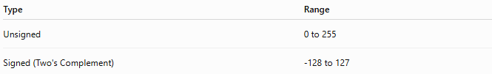
Type | Range
Unsigned | 0 to 255
Signed (Two's Complement) | -128 to 127
Unsigned numbers provide a larger positive range because no bits are reserved for a sign.

Real-Life Applications

Signed Numbers
# Source: AI Source: Provided by: [Data Path: Persons Table -> ID Column: 1, Name_En Column: Motasem Essam] -> From: [ChatGPT] on [7/11/2026]
Used for:
- Temperature above and below zero
- Elevation above and below sea level
- Bank balances (credit and debt)
- Profit and loss
- Mathematical calculations involving negative values

Unsigned Numbers
# Source: AI Source: Provided by: [Data Path: Persons Table -> ID Column: 1, Name_En Column: Motasem Essam] -> From: [ChatGPT] on [7/11/2026]
Used for:
- Counting objects
- Population
- Age
- Distance
- Quantity of products
- Inventory
- File sizes and memory addresses (in computing)

Signed Numbers vs. Unsigned Numbers
# Source: AI Source: Provided by: [Data Path: Persons Table -> ID Column: 1, Name_En Column: Motasem Essam] -> From: [ChatGPT] on [7/11/2026]
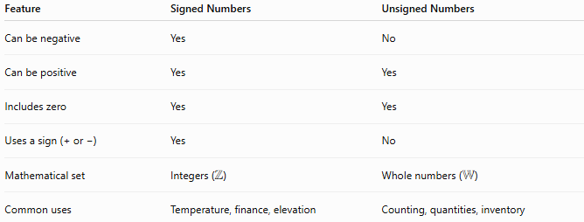
Feature | Signed Numbers | Unsigned Numbers
Can be negative | Yes | No
Can be positive | Yes | Yes
Includes zero | Yes | Yes
Uses a sign (+ or −) | Yes | No
Mathematical set | Integers ($Z$) | Whole numbers ($W$)
Common uses | Temperature, finance, elevation | Counting, quantities, inventory

Advantages

Signed Numbers
# Source: AI Source: Provided by: [Data Path: Persons Table -> ID Column: 1, Name_En Column: Motasem Essam] -> From: [ChatGPT] on [7/11/2026]
- Represent positive and negative values.
- Suitable for calculations involving gains and losses.
- Essential for many mathematical and scientific applications.

Unsigned Numbers
# Source: AI Source: Provided by: [Data Path: Persons Table -> ID Column: 1, Name_En Column: Motasem Essam] -> From: [ChatGPT] on [7/11/2026]
- Simpler representation.
- Larger positive range for the same number of bits in computing.
- Ideal for counting and quantities that cannot be negative.

Key Points
# Source: AI Source: Provided by: [Data Path: Persons Table -> ID Column: 1, Name_En Column: Motasem Essam] -> From: [ChatGPT] on [7/11/2026]
- A signed number has a positive or negative sign.
- An unsigned number has no sign and cannot represent negative values.
- Zero belongs to both signed and unsigned number systems.
- Signed numbers are represented by the set of integers ($Z$).
- Unsigned numbers correspond to the set of whole numbers ($W$).
- In computer systems, signed and unsigned integers have different value ranges for the same number of bits.

Conclusion
# Source: AI Source: Provided by: [Data Path: Persons Table -> ID Column: 1, Name_En Column: Motasem Essam] -> From: [ChatGPT] on [7/11/2026]
Signed numbers represent values that may be positive, negative, or zero, making them suitable for situations involving direction, change, or comparison relative to zero. Unsigned numbers represent only nonnegative values and are commonly used for counting and measuring quantities. Understanding the distinction between signed and unsigned numbers is important in mathematics, computer science, programming, and digital systems.

